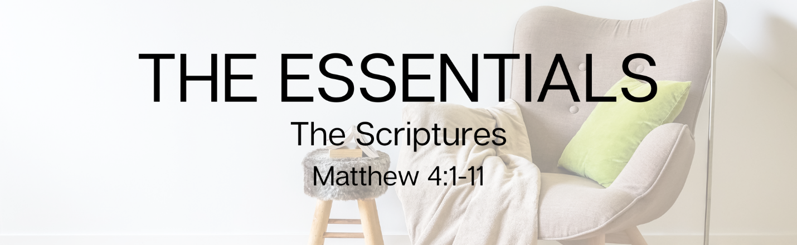

“WEEK #3 - THE SCRIPTURES”
Preached: September 26, 2021
Series: “The Essentials”
Scripture: Matthew 4:1-11

SECTION 1 – SMALL GROUPS QUESTIONS
- Check in question – As a follow up to last week – have you done anything specific or different this week in an attempt to love your neighbor?

- Do you have any kind of regular rhythm in your life centered around spending time in the Scriptures? If so, what does that look like? If not, what might it look like?

- What Scriptures, if any, do you have committed to memory? Has this practice proven to be helpful? How so?

- When the stresses of life, the challenges of the day and the difficult decisions are upon you, what role does Scripture play if any? Based on this passage and Jesus’s responses to the Devil, what might we learn?

- What of the three temptations are most prominent in your walk? How might you respond to those temptations differently after seeing Jesus’s response?

- Right before these temptations take place, Jesus experienced the amazing gift of baptism. And immediately after he experiences this high high, The Spirit leads him into the desert to be tempted. Has it been your experience that following the high highs in life, you can stumble in your spiritual life?

- How do the waters of Baptism prepare Jesus for what’s next? How do the waters prepare you?

SECTION 2 – PRAYER
Take some time to share some prayer requests with one another and then spend some time praying for each other.

SECTION 3 - MOMENT ON MISSION
Partners in the community – Sarah’s House is committed to ending the cycle of homelessness and abuse in women and children through comprehensive case management, counseling, educational classes, prenatal care, and resources throughout pregnancy and beyond. If you have participated in the baby bottle campaign here at church, you have been a part of helping this great organization. For more information about how you might be able to contribute to them on a more consistent basis, check out their website - sarahshousesimi.org

On your own – Write out a short passage of Scripture that you want to commit to memory and place it on your bathroom mirror, or on a sticky note in your car or on the dash, or a new screen saver on your computer with a Word from the Bible. Simply put – see what you can do to put the Word of God in front of you more often this week.

