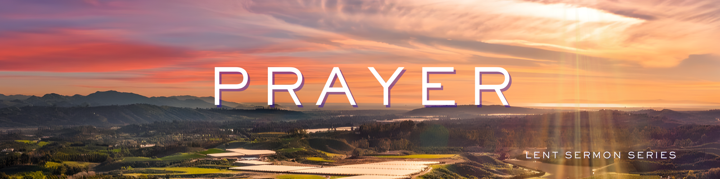
“Prayer – Kingdom Power Glory”
Growth Group Questions for Week 6 in a 6-week Series
(please notice last section requests your feedback)

Preached: March 22, 2026
Scripture: Matthew 6:9-13 and 1 Chronicles 29:11
Series: “Prayer” – Week 6 of 6

PART 1 - REFLECTION QUESTIONS
- What does the word “kingdom” suggest about God’s role and authority?

- How do “power” and “glory” differ, and how are they related?

- What is the significance of the phrase “forever and ever”?

- How does declaring God’s kingdom shape our understanding of His control over the world? How does declaring God’s kingdom shape our understanding of His control over my world?

- Do you think acknowledging God’s power counteracts our tendency to rely on ourselves? Why or why not?

- What does it look like to give God the glory in both words and actions?

- How can you intentionally recognize God’s kingdom in your daily rhythms this week?

- Are there parts of your life where you struggle to trust in God’s power instead of your own? How can we learn to let go of the power and pass it on to Jesus?

- What would it look like for your prayers to consistently end with worship and surrender?

- How might your prayer life change if you truly believed everything belongs to God - His kingdom, power, and glory?

PART 2 - PRAYER TIME
Take time to pray for one another. As a group, how can you encourage one another to live in a way that reflects God’s kingdom, power, and glory? Pray that over each other this week as you close your time together.
PART 3 – PRAYER PRACTICE

The Labyrinth
A labyrinth is an ancient, unicursal geometrical pattern used as a tool for walking meditation, prayer, and self-reflection. Unlike a maze, which is a puzzle designed to confuse with dead ends, a labyrinth has a single continuous path leading to a center and back out, designed to help you find your way. It is used in many spiritual traditions as a metaphor for the journey to the center of Christ’s heart.

How to Walk a Labyrinth: Step-by-Step Instructions
There is no "right or wrong" way to walk a labyrinth, but these guidelines are often used:

- Prepare/Set Intention: Before entering, take a moment to pause at the entrance to center yourself, breathe, and set an intention or ask a question.
- Releasing (Path In): As you walk toward the center, use the time to let go of the noise of the world, stress, or worries. Walk at your own natural pace, whether slow or fast.
- Receiving (The Center): Pause and stay in the center as long as you like. This is a place for reflection, prayer, listening, or receiving insight.
- Returning (Path Out): Retrace the same path back out. This represents integrating the insights you received and carrying them back into your daily life.
- Reflect/Exit: After exiting, take time to reflect on your experience, perhaps through journaling or drawing.
PART 4 – THURSDAY PRAYER NIGHT
On Thursday March 26 at 7:00pm, we will gather in the Sanctuary and walk along the Labyrinth together. All are invited to join us as we experience the power of praying together.
PART 5 – WORSHIP FEEDBACK REQUESTED
We are in a time in the church’s growth where we look at everything we do and reflect on ways in which we might be able to add additional people to our congregation. As part of that discussion, there has been an initial conversation about shifting the starting time of our weekly worship gathering from 9:00am to 10:00am.
To discuss in your group:
- How would you respond to a shift in our worship time from beginning at 9:00am to 10:00am?

- Would this shift make it easier or harder for you and your family to attend regularly?

- Do you have any concerns to share about a later starting time?

The elders of the church are simply trying to hear as many points of view as possible on this subject. As the Growth Group Leader – would you be willing to summarize the results of your conversation in one paragraph and send that feedback to Pastor Keenan by Sunday, March 29th?
Thanks in advance for your help. KeenanB@MPCLife.org

