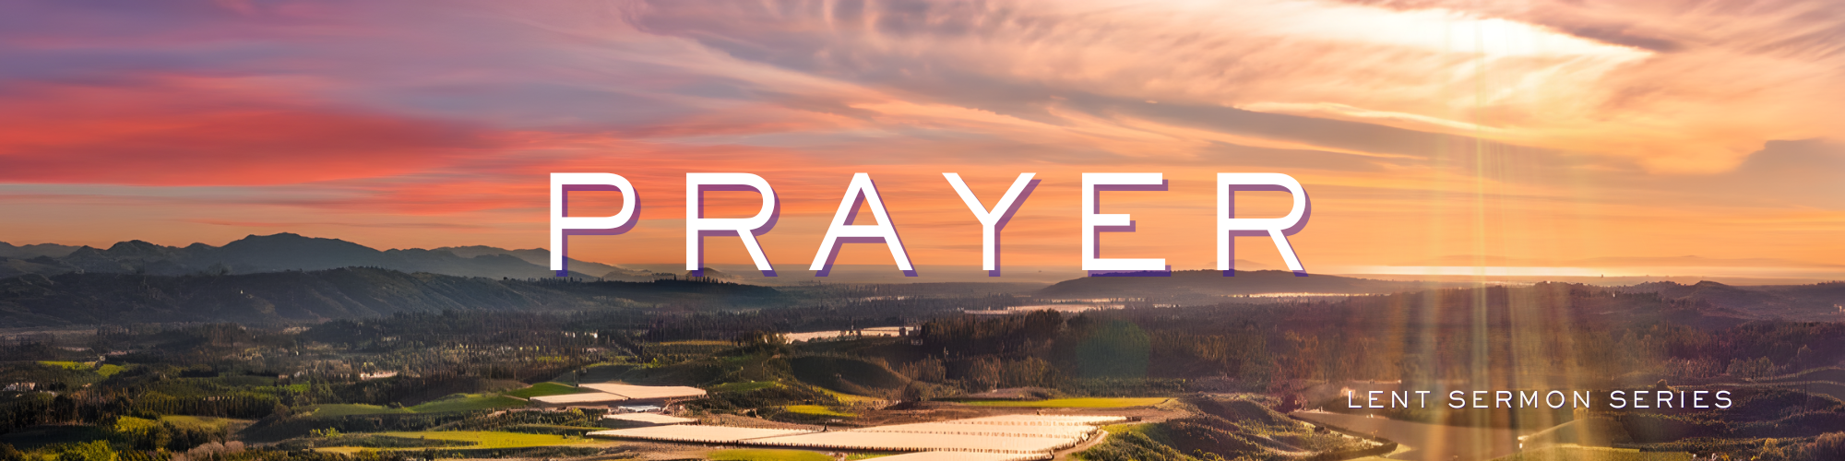
“Prayer – Forgiveness”
Growth Group Questions for Week 4 in a 6-week Series

Preached: March 8, 2026
Scripture: Matthew 6:12, 14-15
Series: “Prayer” – Week 4 of 6

PART 1 - REFLECTION QUESTIONS
- In Matthew 6:12, what two “directions” of forgiveness are being presented in the Lord’s Prayer?

- Why do you think Jesus repeats and expands on forgiveness again in Matthew 6:14- 15 right after the prayer? Does that addition change what Matthew 6:12 is trying to communicate?

- What words or phrases in these verses stand out to you most? Why?

- What does it mean where the verse says, “forgive us our debts”? What kinds of “debts” might Jesus be referring to?

- What are the differences between “debts” “trespasses” and “sins?” Why do different translations of the Bible translate those ideas differently?

- How does our willingness (or unwillingness) to forgive others affect our relationship with God according to these verses?

- Is forgiving others something you find easy or difficult? Why does it sometimes seem easier to carry around a grudge?

- Can you think of a time when you have experienced forgiveness from someone? How did you respond? What emotions did you experience?

- Are there practical steps you can take to grow in forgiveness when someone hurts you / betrays you / disappoints you?

- How might practicing forgiveness change relationships in our families, churches, or communities?

PART 2 - PRAYER TIME
Take time to pray for one another. Spend time asking God to reveal places in your life where you might need to begin the process of forgiveness for someone. Invite group members to share and pray for one another in this challenging part of the Christian life.

PART 3 –PRAYER PRACTICE

Description of Visio Divina
Visio Divina (Latin for “divine seeing”) is a contemplative prayer practice that invites people to encounter God through sacred images or visual art, similar to how Lectio Divina helps people encounter God through Scripture.
The prayerful practice happens as a person slowly observes an image - such as sacred art, a photograph, or a scene from nature - while asking the Holy Spirit to reveal spiritual insight. Instead of analyzing the image intellectually, the participant looks with openness and allows God to speak through what they notice, feel, or imagine.

This practice is rooted in the Christian tradition of contemplation and helps believers become more attentive to God’s presence in the world. Many practitioners use artwork depicting scenes from the life of Jesus Christ, biblical stories, or symbolic Christian imagery.

Basic Steps of Visio Divina
- Prepare and Pray
Begin with a moment of silence and ask God to guide your attention and reflection.
- Look (Observation)
Slowly observe the image. Notice colors, shapes, people, emotions, movement, and details. Avoid rushing.
- Reflect
Ask questions such as:
  - What part of the image draws my attention?
  - What emotions or memories arise?
  - Where might God be speaking through this image?
- Respond in Prayer
Speak to God about what you noticed or felt. This may become gratitude, confession, intercession, or worship.
- Rest in God
Spend a few moments in silence, simply being present with God.

PART 4 – THURSDAY PRAYER NIGHT
On Thursday March 12th at 7:00pm, we will gather in the Sanctuary and practice “Visio Divina” together. All are invited to join us as we experience the power of praying together.

