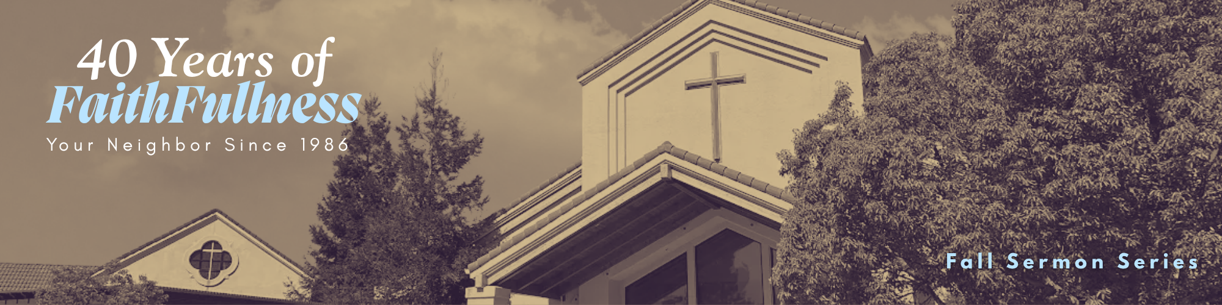

“FaithFull Through Your Storms”
Week 5 in a 9-week Series

Preached: October 18, 2026
Scripture: Mark 4:35-41
Series: “40 Years of FaithFullness” – Week 5 of 9

SECTION 1 – GROWTH GROUP QUESTIONS
- Have you ever experienced an unexpected situation that frightened you? What did you do? How did you respond?

- When life becomes overwhelming, what is your first response: worry, prayer, seeking help, or trying to solve the problem yourself?

- What stands out to you about the fact that Jesus was sleeping during the storm? What do you think this reveals about him and his relationship with His Father?

- In verse 38, the disciples ask Jesus, “Teacher, do you not care that we are perishing?” What does this question reveal about their understanding of Jesus at this point?

- Have you ever experienced a time when God seemed silent or distant during a difficult season? How did you respond?

- What is the difference between believing that Jesus is present during a storm and believing that he will immediately take the storm away?

- What does this passage teach us about the relationship between fear and faith? Does having faith mean we will never experience fear?

- The disciples were experienced fishermen, yet this storm frightened them. What does this teach us about the limits of our own abilities and experience?

- How can our congregation help people in the community who are experiencing personal storms, such as grief, illness, family conflict, or uncertainty about the future?

SECTION 2 – PRAYER
Spend time praying for each other. What are the storms that are facing you? How can God enter the storms with you? How can we stand with others in the storms they are going through? Pray for the storms around people in your group as well as people that are close to you.

SECTION 3 – ADDITIONAL RESOURCES
MUSIC - Are you feeling the need for some new worship music to add to your playlist? If you have Spotify, you can go to my Spotify account, and you can hear all the music from this series thus far. Just follow SpecialKPastor on Spotify and click on “40 Years of FaithFullness”

