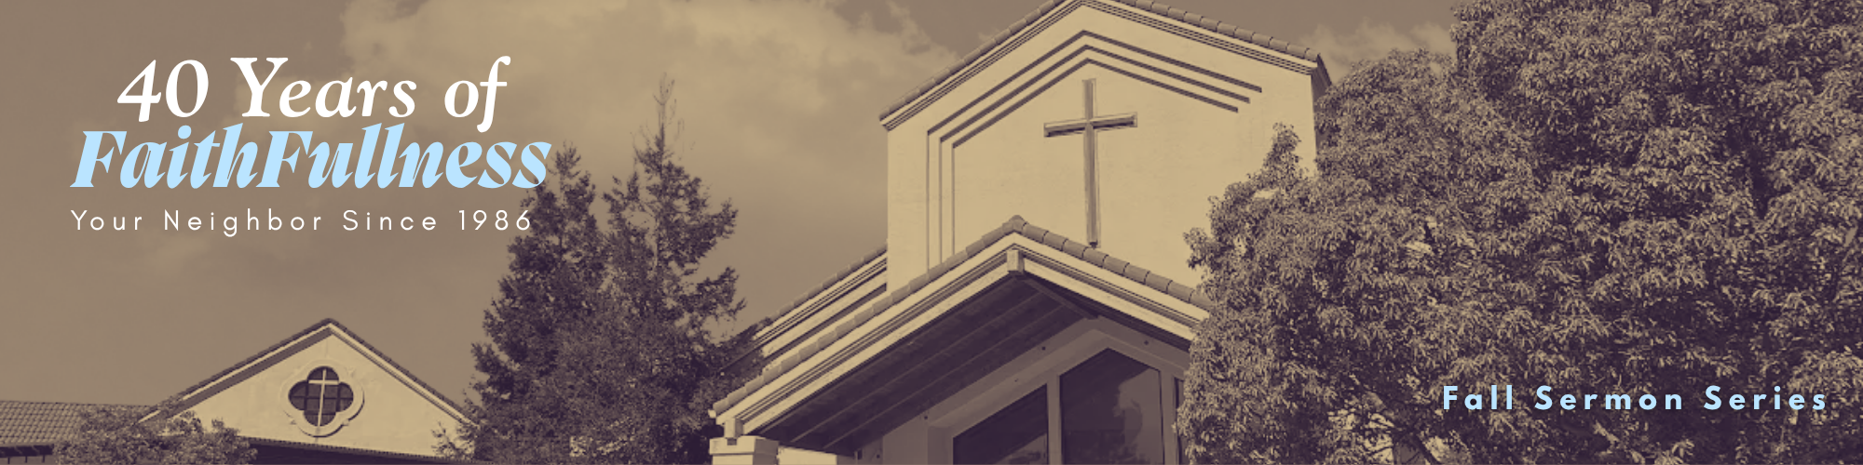

“FaithFull in Our Healing”
Week 4 in a 9-week Series

Preached: October 11, 2026
Scripture: Mark 5:25-34
Series: “40 Years of FaithFullness” – Week 4 of 9

SECTION 1 – GROWTH GROUP QUESTIONS

- When you were a kid, did you ever have a cast for a broken bone? Was it a story of adventure or another kind of story? Have some fun sharing early in life “battle wounds.”

- What do you think were the motivations behind the woman reaching out to touch Jesus’ cloak?

- Is there a difference between believing that Jesus can help us and trusting Jesus enough to reach out to Him?

- What keeps you from actually reaching out? What helps you have the courage to reach out?

- Have there been times when you have approached Jesus quietly, like this woman, rather than asking for help publicly? What was that experience like?

- What might keep people from reaching out to Jesus when they are hurting?

- How might this woman's experience speak to people who feel overlooked, ashamed, or forgotten? Do you know anyone that fits that description? How can you help others to see the power of reaching for Jesus?

- How can our church become better at noticing and caring for people who are suffering quietly?

SECTION 2 – PRAYER
Spend time praying for each other. Where do you need to “reach out and touch” Jesus in faith right now? Is there one area of your life where you need to trust Jesus, even when you don't know what the outcome will be? Spend time encouraging each other – especially those who have been waiting a long time for God's help.

SECTION 3 – SERVING THE CHURCH
Trunk-or-Treat is coming on Saturday October 24th. What an incredible opportunity to serve our community by putting some simple decorations on the trunk of your car, handing out some candy, and encouraging parents and kids by simply being present. Sign up here for your chance to serve.

SECTION 4 – ADDITIONAL RESOURCES
MUSIC - Are you feeling the need for some new worship music to add to your playlist? If you have Spotify, you can go to my Spotify account, and you can hear all the music from this series thus far. Just follow SpecialKPastor on Spotify and click on “40 Years of FaithFullness”

