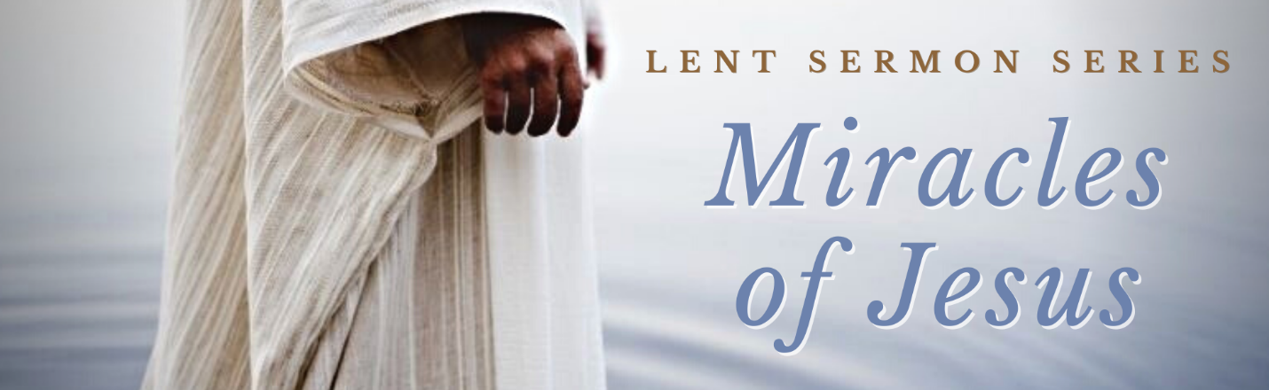

“WEEK #6 – It’s My Palm Sunday and I’ll Cry if I Want To”

Preached: April 2, 2023
Preacher: Dave Wilkinson
Series: “Miracles of Jesus” – Lent 2023
Scripture: John 9:1-3, Luke 19:36-44
SECTION 1 – SMALL GROUPS QUESTIONS

      - What has gone on in your life or in the world that causes you to question whether God is really loving or really powerful? Share it with the group and then at the end of your meeting time, pray for one another for those places in your lives and in the world.

      - As Jesus enters Jerusalem on Palm Sunday he is greeted by a joyful crowd. Jesus could have indulged Himself in this moment. But when He sees the city, He begins to weep. He knows that in rejecting Him the city will be left to accept the consequences. If we reject the Living God who comes to us, we will be left with the consequences. It’s a natural consequence of rejection. What are the consequences for Jerusalem? What are the consequences for people today?

      - What does it say to you that Jesus weeps over the city?

      - Suffering raises questions of fairness – why bad things happen to good people and good things happen to bad people. Some people look for pat answers that are both reassuring and wrong. What are some pat answers you have heard?

      - What do the disciples want to know in John 9? How do they want to be reassured?

      - What is the disciples’ assumption? Do we make the same assumption? Why or why not?

      - The disciples and the blind man all want to know that answer to the question of the cause of suffering. But Jesus doesn’t provide it although He could have. Why do you think this is? In John 16:33 Jesus says that He “has overcome the world.” Do you ever wish He had explained the world a bit more?

      - Scripture demonstrates repeatedly that God is not bound by our expectations. We can’t always predict what He will do. C.S. Lewis, while he was grieving the death of his wife, asked: “What do people mean when they say, ‘I’m not afraid of God because I know He is good?’ Haven’t they ever been to the dentist? God is good. But His goodness and our immediate happiness are not always the same thing. What do you think God is doing in your life for your long-term benefit that hurts right now? How do you handle that?

      - This man started his day as a blind beggar and finished it as a seeing citizen in the Kingdom of God. God writes the last chapter, not our suffering. What does Easter say is the last chapter for you and for your pain?

SECTION 2 – PRAYER

Pray about all that has come up in discussing this passage today.
- Places of pain in people’s lives and in the world.
- Areas where you might be called to minister to people in pain
- Areas in your life that may be stretching your faith.
- People you might invite to MPC for Easter

