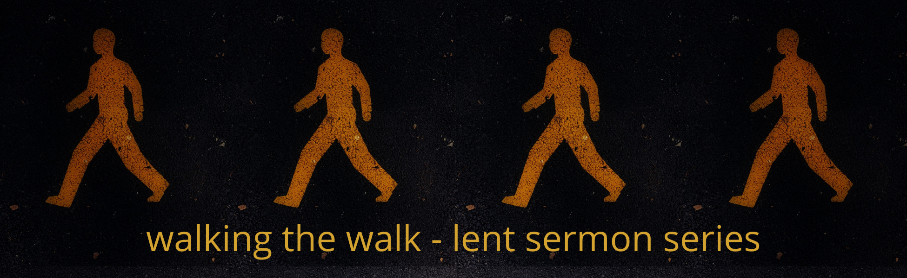

2022 Lenten Small Group Questions
Week 6 – April 10, 2022 - “The Journey”
Scripture: Matthew 21:1-11
Preacher: Keenan

To start your time together….
Revisit last week’s message - Did you have any moments of salience this week that were helpful on your spiritual walk? Did the quiet time with Jesus help you have a better week?

Scripture
Matthew 21:1-11
As they approached Jerusalem and came to Bethphage on the Mount of Olives, Jesus sent two disciples, ² saying to them, “Go to the village ahead of you, and at once you will find a donkey tied there, with her colt by her. Untie them and bring them to me. ³ If anyone says anything to you, say that the Lord needs them, and he will send them right away.”
⁴ This took place to fulfill what was spoken through the prophet:
⁵ “Say to Daughter Zion,
‘See, your king comes to you,
gentle and riding on a donkey,
and on a colt, the foal of a donkey.’”
⁶ The disciples went and did as Jesus had instructed them. ⁷ They brought the donkey and the colt and placed their cloaks on them for Jesus to sit on. ⁸ A very large crowd spread their cloaks on the road, while others cut branches from the trees and spread them on the road. ⁹ The crowds that went ahead of him and those that followed shouted,
“Hosanna^{[b]} to the Son of David!”
“Blessed is he who comes in the name of the Lord!”
“Hosanna^{[d]} in the highest heaven!”
¹⁰ When Jesus entered Jerusalem, the whole city was stirred and asked, “Who is this?”
¹¹ The crowds answered, “This is Jesus, the prophet from Nazareth in Galilee.”
Reflection Questions

- Have you walked a Labyrinth as a spiritual practice before? If you have, how was it? If not, is there an interest in hopping on over to MPC and giving it a try? Why or why not?

- Palm Sunday was the beginning of the journey of Holy Week for Jesus. As you read Matthew 21:1-11, what parts of the journey do you notice? Is it hard to imagine that Jesus could experience such a high high and then be crucified just a few days later?

- Where are you on your spiritual journey? Do you feel close to God or far away? If you feel close, how do you continue to remain close? If you are far off, how can you begin your journey to coming closer to God?

- While you are on your own spiritual journey, there are other people on their spiritual journey at the same time. On that journey, there are people who will help you on your journey and those who seem to somehow knock us off our path. How do you respond to people in these two groups? How can you be helpful to others on the journey they are on? How can you make sure that you are not a distraction to others on the journey they are on?

- What does the journey of “Holy Week” look like for you? What are ways that Christ invites you to be a part of the journey of remembering all that took place some 2,000 years ago?

- What would it look like for your small group to take a trip to the Church Labyrinth and walk it together?

Other Resources
“Spiritual Disciplines Handbook – Practices that Transform Us.”
by Adele Ahlberg Calhoun

“Celebration of Discipline – The Path to Spiritual Growth.”
by Richard Foster

