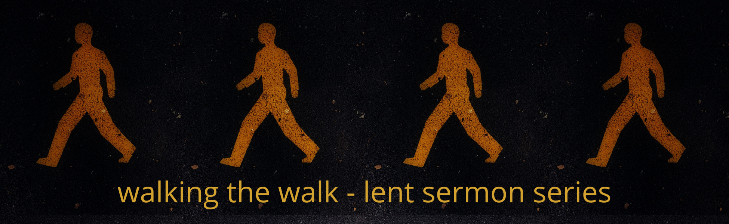

2022 Lenten Small Group Questions

Week 4 – March 27, 2022 - “Making Space for the Father Through Fasting”
Scripture: Romans 8:1-6
Preacher: Jason Miller

Scripture: Romans 8:1-6
“There is therefore now no condemnation for those who are in Christ Jesus. 2 For the law of the Spirit of life has set you free in Christ Jesus from the law of sin and death. 3 For God has done what the law, weakened by the flesh, could not do. By sending his own Son in the likeness of sinful flesh and for sin, he condemned sin in the flesh, 4 in order that the righteous requirement of the law might be fulfilled in us, who walk not according to the flesh but according to the Spirit. 5 For those who live according to the flesh set their minds on the things of the flesh, but those who live according to the Spirit set their minds on the things of the Spirit. 6 For to set the mind on the flesh is death, but to set the mind on the Spirit is life and peace.”

Reflection Questions

- How does the promise of Romans 8:1- "That there is now no Condemnation", affect the way that you see yourself?

- What/where are the places you turn to find comfort and keep calm?

- Why do these things feel comforting- What anxiety/need are they helping meet?

- What is the good in these things, and how are they potentially toxic?

- What is one place you might engage a small denial, a fast from your source of comfort?

- What might it look like to invite God to fill this new available space?

- Who will you invite to have the freedom to journey alongside of you and engage honestly, to ask how these fasts are going, how you are making space for God's voice and presence, what you are learning?

Prayer Exercise
As you have discussed the reflection questions above, what are areas of your life that could use prayer over?

Spend time praying for each other as you consider where God might be leading you to participate in fasting from certain parts of your life.

Other Resources
“Spiritual Disciplines Handbook – Practices that Transform Us.”
by Adele Ahlberg Calhoun

“Celebration of Discipline – The Path to Spiritual Growth.”
by Richard Foster

