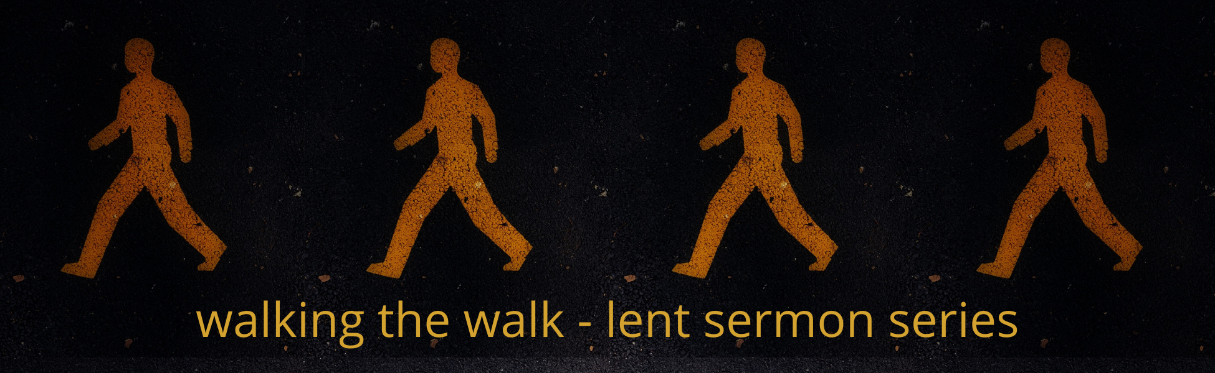

2022 Lenten Small Group Questions

Week 3 – March 20, 2022 - “Sabbath Keeping”
Scripture: Exodus 20:8-11
Preacher: Keenan Barber

Scripture: Exodus 20:8-11
“Remember the Sabbath day by keeping it holy. 9 Six days you shall labor and do all your work, 10 but the seventh day is a sabbath to the Lord your God. On it you shall not do any work, neither you, nor your son or daughter, nor your male or female servant, nor your animals, nor any foreigner residing in your towns. 11 For in six days the Lord made the heavens and the earth, the sea, and all that is in them, but he rested on the seventh day. Therefore, the Lord blessed the Sabbath day and made it holy.

Working Definition
“Sabbath is God's gift of repetitive and regular rest. It is given for our delight and communion with God. Time for being in the midst of a life of doing particularly characterizes the Sabbath.” (Calhoun, 40)

Prayer Exercise
As a review of last week, start your time together as a group with the Prayer of Examen. Have each person in the group share their highs and lows of the last week. Questions to keep in mind as you think about the highs and lows might include:

- Where did I give or receive love this last week?
- How did I withhold love this last week?
- What activity gave me the greatest high?
- Which one made me feel low?
- Where is God present in the midst of those highs and lows?
- How might you invite God into those spaces?

Then pray for each person in the group.

Reflection Questions

- Do you take a Sabbath day of rest as part of your regular weekly rhythm? Why or why not? If you do – what are the benefits and costs? If you don’t – what might the costs and benefits be?

- If you were to spend a day in Rome Italy, you would want to plan out your entire day – so that you could see and experience all that you could in one day. If you were to take on the task of planning out a Sabbath day of rest, what would be a part of your day? What would be hard to leave behind for the day?

- You might have kids or grandkids or nieces of nephews who participate in youth sports or other activities. If those activities are happening on Sundays, what does that mean in terms of trying to keep the Sabbath? Do we need to discontinue youth sports? Do we need to try and do Sabbath alongside youth sports? Can youth sports be a part of Sabbath rest? If you don’t have young kids, and a young mom or dad from the congregation came and asked you about this, how would you advise them?

- Read Mark 2:23-28. At the end of this short passage, Jesus says, “The Sabbath was made for man, not man for the Sabbath.” What do you think this means?

Other Resources
“Spiritual Disciplines Handbook – Practices that Transform Us.”
by Adele Ahlberg Calhoun

“Celebration of Discipline – The Path to Spiritual Growth.”
by Richard Foster

“Sabbath as Resistance – Saying NO to the CULTURE OF NOW.” By Walter Brueggemann

