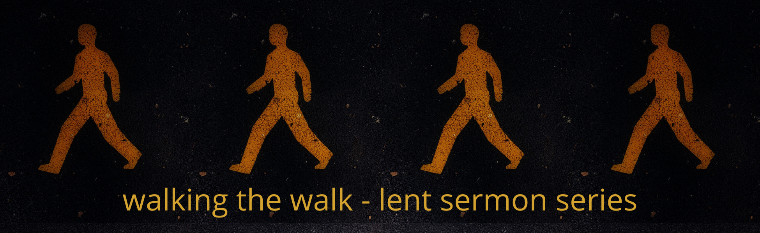

2022 Lenten Small Group Questions

Week 2 – March 13, 2022 - “Prayer of Examen”
Scripture: Philippians 1:9-1
Preacher: Keenan Barber

Scripture: Philippians 1:9-11
“And this is my prayer: that your love may abound more and more in knowledge and depth of insight, 10 so that you may be able to discern what is best and may be pure and blameless for the day of Christ, 11 filled with the fruit of righteousness that comes through Jesus Christ—to the glory and praise of God.”

Working Definition
The Prayer of Examen is a practice for discerning the voice and activity of God within the flow of our day or week. It is a vehicle that creates deeper awareness of God given desires in our own lives. When early Christians began this practice, the focus was on two big words: consolation and desolation.

Prayer Exercise
Start your time together as a group with the Prayer of Examen. Have each person in the group share their highs and lows of the last week. Questions to keep in mind as you think about the highs and lows might include:

- Where did I give or receive love this last week?
- How did I withhold love this last week?
- What activity gave me the greatest high?
- Which one made me feel low?
- Where is God present in the midst of those highs and lows?
- How might you invite God into those spaces?

Then determine the best way to pray for each person in the group.

Reflection Questions

- How is your prayer life? If someone you didn’t know was able to watch every minute of your day, when would they observe you praying?

- Why is having a regular rhythm of prayer hard? What might make it easier?

- Do you know anyone who is a person of prayer – someone who prays in and through every situation they come into contact with? Do you admire them and want to be like them or are they just a different flavor of Christian than you?

- As you read these few verses from Paul’s letter to the Philippians, what strikes you about what Paul prays for?

- When you pray for someone, are any of these ideas present as you pray for them? Why or why not?

Other Resources

“Spiritual Disciplines Handbook – Practices that Transform Us.”
by Adele Ahlberg Calhoun

“Celebration of Discipline – The Path to Spiritual Growth.”
by Richard Foster

“Spiritual Disciplines Devotional – A Year of Readings.”
by Valerie E. Hess

