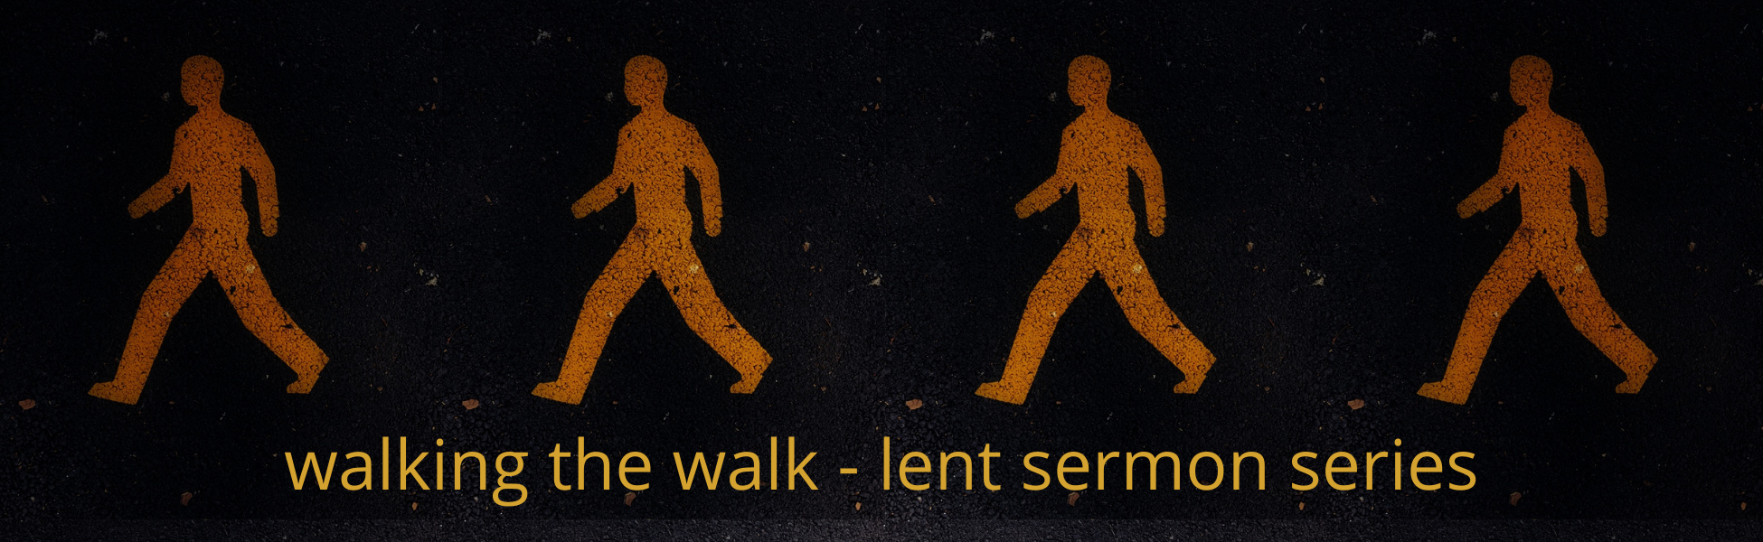

2022 Lenten Small Group Questions

Week 1 – March 6, 2022
“A With God Life”
John 15:1-7
Pastor Care Crawford

- Which image best describes your relationship with God right now?

Why?
What feelings does this evoke?

If you could choose to be somewhere else, other than what you chose, which image would you “want”?

- When you think about the word “DISCIPLINES” …what do you think? Is it a welcomed word for you?

- In ‘Walking the Talk” this Lent- we will look at specific spiritual practices and disciplines to help you go deeper and experience new ways of being with God. What is the way you “best hear God” these days?

through nature? through Scripture? through silence? through serving? through study? through giving? through adventure? what else?

- Have you known someone who talks the walk but themselves don’t ‘walk it’ and it seems obvious?

What is it like to be around someone like that?

How does that make you feel?

- What are the biggest obstacles in your life to walking the walk?

- If you had to rate your own spiritual formation journey today on a scale of 1-10, 1-low, 10-high, where would you assign yourself?

- If you knew God was sitting in a chair in this small group and you could ask 1 question… what would you ask of God?

- What is your definition of abiding? How are you doing with that?

The aim of spiritual formation is not behavior modification but the transformation of all those aspects of you and me where behavior comes from... a circumcision of the heart. It asks the question 'What kind of person am I going to be? Willard concludes, “Our spiritual formation is the process of establishing the character of Christ within us. And that's all it is.”

- What are your thoughts about the quote above?

Pastor Care said, "Spiritual formation is a curriculum for Christlikeness… being like Christ…and to be like Christ we have to know Christ, and to know Christ, we have to spend time with Him. Spiritual disciplines and spiritual practices help us do this.”

- What is your reaction to this?
“Bring it on”
“Maybe for someone else”
“Doesn’t sound easy but I am 'in’ “
“I’m lost in all this”
“What should I try first?"

