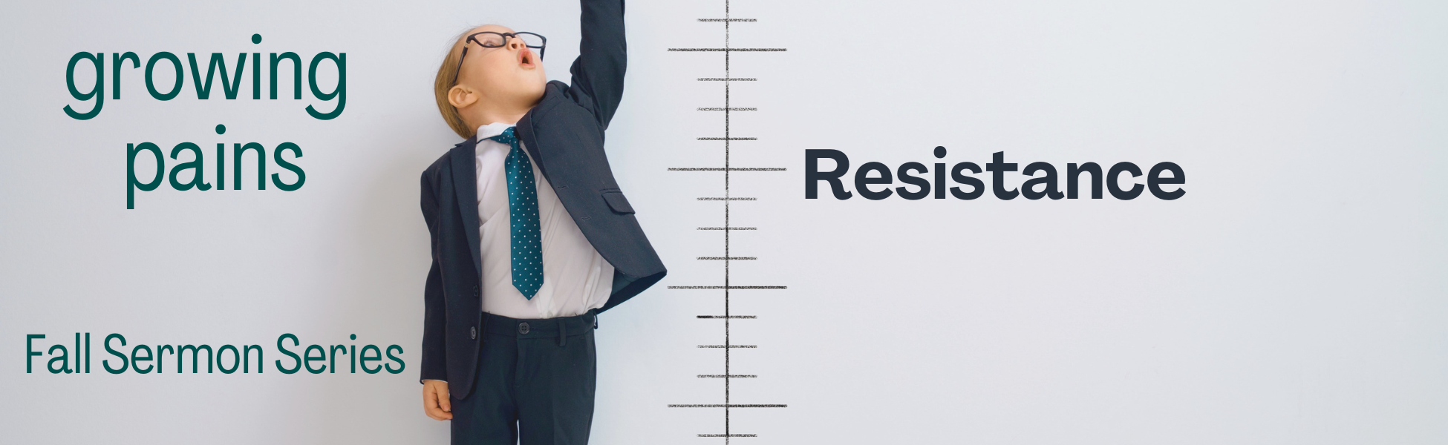

“WEEK #7 – SERVING”

Preached: October 23, 2022
Preacher: Sean Meade
Series: “Growing Pains”
Scripture: Acts 6:1-7

SECTION 1 – SMALL GROUPS QUESTIONS

- Why do you think about the conflict in this passage? Have you ever experienced in the church? How was it resolved?

- There was a basic need in the early church – to make sure that everyone, including the widows, were being given a fair amount of food. What are some of the basic needs at MPC that you’re aware of and how are those being met?

- The apostles said “It would not be right for us to neglect the ministry of the word of God in order to wait on tables”. What do you think about that statement? Is it offensive? What are your thoughts about the saying “Only do what only you can do”?

- Sean talked about Friendly Chapel Church and the story of Brother Paul Holderfield. What stood out to you in that story? Have you ever known someone who really embodied serving like that?

- How do you serve God? Is there any area of your life where you feel like you could serve but currently aren’t? Is there some new way that you feel God might be calling you to serve Him right now?

- Luke tells us that the early church grew in numbers daily as a result of the disciples serving. In what ways have you seen MPC grow as a result of service? In what ways do you think we could improve or step up how we serve others – and do you think that might lead to growth in our church?

SECTION 2 – PRAYER

Spend time in prayer, praying for each other. Take time to thank God for all the amazing ways that people are already serving at MPC. Really take a moment to reflect on all the different areas where people serve, both seen and unseen. Then reflect on how God might grow our spirit of service at MPC, and pray that God would show us new ways to serve and that He might move the hearts of those who aren’t yet serving. All for His Glory!

