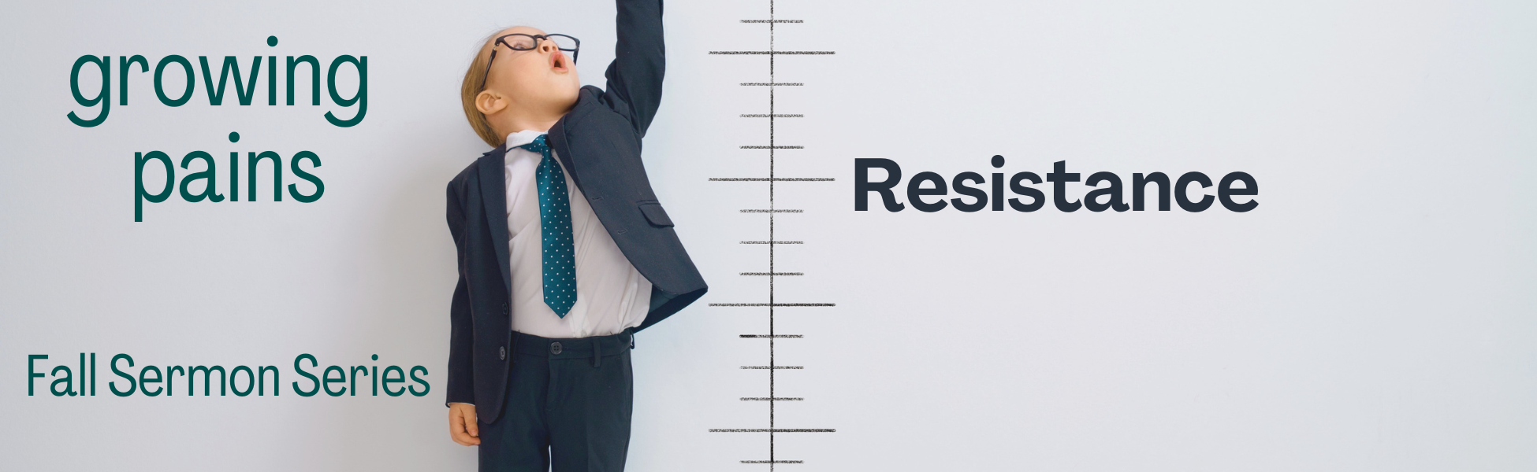

“WEEK #6 – RESISTANCE”

Preached: October 16, 2022
Preacher: Keenan Barber
Series: “Growing Pains”
Scripture: Acts 4:1-22

SECTION 1 – SMALL GROUPS QUESTIONS

- Why do you think the “authorities” in this passage arrest John and Peter? What crime do they hope to get them on? If not a crime, what brings fear to them in such a place of agitation that they’ll throw them in jail overnight?

- A lame man is healed. The Good News of the Gospel is preached. The men who did the healing are arrested and they are threatened with imprisonment if they don’t stop sharing with other people. What do you think would be the consequences if you proclaimed the Gospel BOLDLY to the people around you? What would be the prison they would try to put you in if you were found “guilty?”

- Who has authority in your life? When someone enquires about what power directs your life, how do you respond?

- The word & picture Peter paints as he quotes the OT is that Jesus is the “cornerstone.” What does this mean? Is Jesus the cornerstone of your life? How would people know that? If not Jesus, what is acting as your cornerstone in place of Jesus? Your career? Your family? Your financial portfolio?

- What do you speak boldly about? With extreme confidence? How might you grow in boldness for Jesus?

- Peter and John are referenced as “common” in their training – not particularly or uniquely qualified – to speak about things theological. Do you think they have the ability to speak with “authority?” Do you think you are uniquely qualified to speak about what you know about Jesus? Why or why not?

SECTION 2 – PRAYER

Spend time in prayer. Praying for each other. Simple. Nothing complicated. Pray with boldness.

