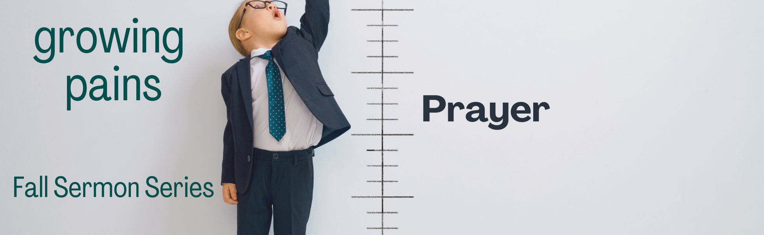

“WEEK #5 – Prayer”

Preached: October 9, 2022
Preacher: Bonnie Boe
Series: “Growing Pains”
Scripture: Acts 4:23-31

SECTION 1 – SMALL GROUPS QUESTIONS

- The new believers were living their lives in new ways. They were responding to the calling to follow Jesus. They were being changed in the process. How have you responded to the call to follow Jesus? How have you, or have you not, been changed in the process?

- Do you think prayer together, as the Body of Christ is relevant? Why or why not?

- Praying hard prayers sometimes requires taking chances that can be scary and uncomfortable. How can we honor the knowledge that God is in control over all things and all circumstances in our lives?

- What would it mean for you to be actively used by God?

- The believers came together as one unified entity and lifted their voices to God. In verse 29 they ask for great boldness in preaching God’s Word. How difficult do you find it to share your faith with others? When have you needed boldness to share the Gospel with others?

- The stronger we are, the more united we are, the more the Enemy will try to derail our work for the Kingdom. What are things that we can do to ensure that we remain united as the Body of Christ and not let division hand us over to the Enemy?

- From the sermon, “What is it that would make you bold enough to ask God to come into this place and light our fire?”

SECTION 2 – PRAYER

In your time of prayer today, become the 1st century believers. Lift your voices to the Sovereign God who is in control of everything. Ask Him to send the Holy Spirit to give you, individually, and all of us in our church fellowship, power, and boldness to go forth and preach the Gospel of Jesus to everyone we meet.

