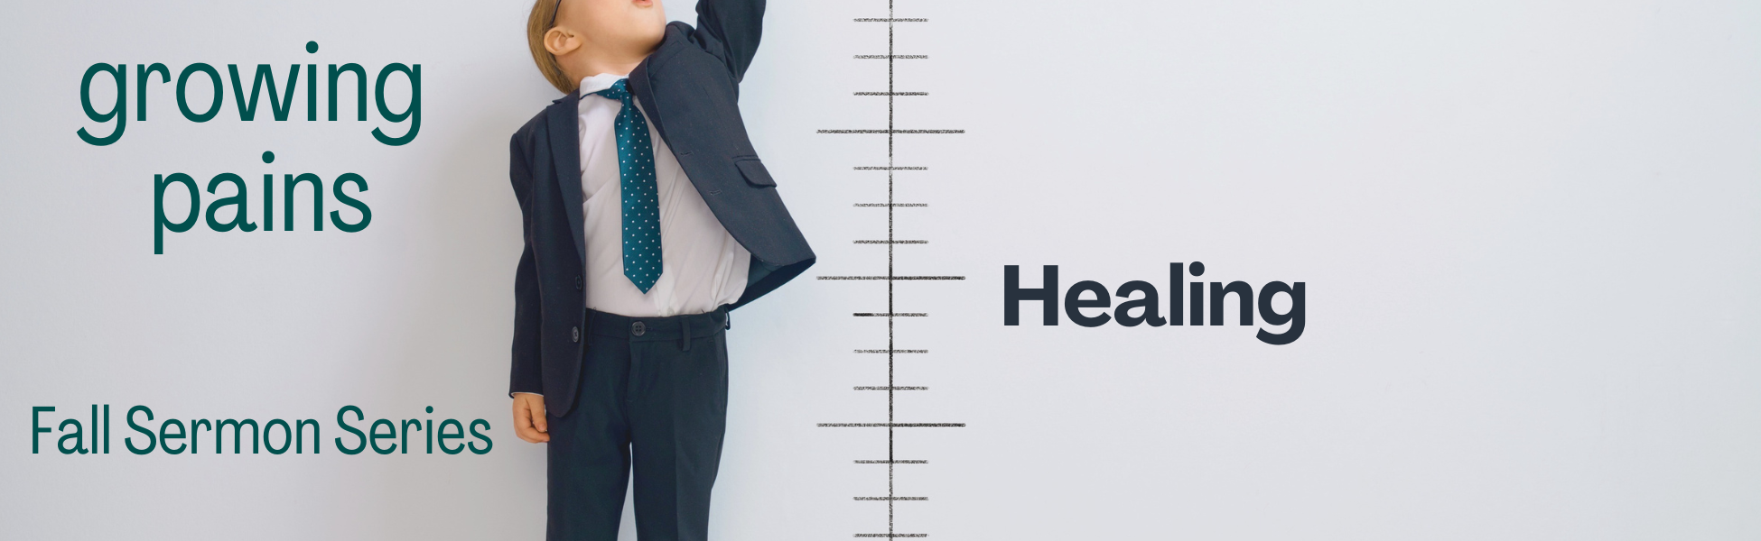

“WEEK #4 – HEALING”

Preached: October 2, 2022
Preacher: Keenan Barber
Series: “Growing Pains”
Scripture: Acts 3:1-11

SECTION 1 – SMALL GROUPS QUESTIONS

Quick note – If you met last week and discussed, “three things you would see in a healthy church,” would you mind sharing those responses with Pastor Keenan? KeenanB@MPCLife.org Thanks.

- In verse 2, Luke tells us that this disabled person was placed in the temple gate called Beautiful – “where he was put every day to beg from those going into the temple courts.” Why do you think that is where he placed himself? Do you think his strategy is smart or flawed? How would you respond to a disabled person begging in our own narthex?

- When you are approached by a homeless person on the street, how do you typically respond? Do you have a standard response that you give everyone, or do you respond differently each time? Based on reading this passage from Acts, are you encouraged to revisit the way in which you respond? Why or why not?

- “Peter looked straight at him.” Do you have a hard time making eye contact with people? Do you think this passage emphasizes actual eye contact or is there something else going on here?

- Peter and John’s response is not to offer money but to offer something else. What do these two offer the disabled man? What would it look like for you to offer that to someone in a similar predicament?

- Have you ever observed someone being healed? Physical healing? Emotional healing? How did you feel as you observed this happening? If you have never seen or been around someone who has experienced healing or you yourself have not experienced that before, what do you think that means?

- If you were to witness a genuine healing, what would a hearty celebration look like? Do you think you would share what you saw with others? Why or why not?

- The last part of verse 10 says, “and they were filled with wonder and amazement at what had happened to him.” When was the last time you felt like this? Why don't we feel like this more often?

SECTION 2 – PRAYER

In your time of prayer today, share areas of your life or areas of the lives of the people around you where healing is needed? Broken relationships? Hard work situations? Physical ailments? Emotional woundedness? Make sure to actually spend time praying for all of these different areas of peoples’ lives.

