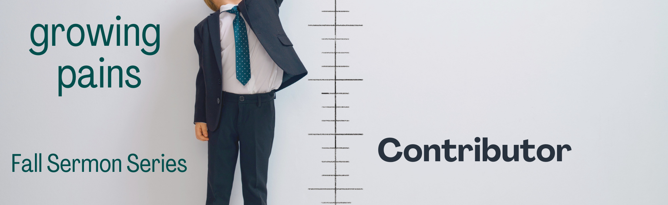

“WEEK #3 – CONTRIBUTOR”

Preached: September 25, 2022
Preacher: Keenan Barber
Series: “Growing Pains”
Scripture: Acts 2:42-47

SECTION 1 – SMALL GROUPS QUESTIONS

- Pastor Keenan started his sermon with this question, “Tell me three things you would see in a healthy church.” Spend a few minutes compiling a list of things the group sees as part of this list. Someone take notes and email your compiled list to KeenanB@MPCLife.org

- Verse 42 reads like this, “They devoted themselves to the apostles’ teaching and to fellowship, to the breaking of bread and to prayer.” What do these four activities look like in your life? What do these four activities look like in your small group? What do these four activities look like in our church?

- Keenan talked a lot about being a contributor as opposed to a consumer. What are ways that you recognize in your own spiritual walk where you find yourself behaving more like a consumer rather than a contributor? How about in your relationship to the church? In relationship to others?

- Why is it so hard to be a contributor? Why is it so easy to fall into the trap of being a consumer?

- How can the Holy Spirit help us in this struggle between being a consumer and being a contributor?

- Identify one area in your life where you want to begin the practice of being a contributor.

SECTION 2 – PRAYER

In your time of prayer today, spend a little time praying for the areas in your life where God might be seeking you to be more a contributor as opposed to a consumer.

